**COMP 4620 Web-Based Information Systems**

**Seminar/Lab 8**

**Calculator WebSocket App**

1. **Objectives**

* Understand how WebSocket works

1. **Calculator**
   1. calculator.html and calculator_ws_server.js

* You can download the files from the Moodle and complete them. You need to complete the code, including the URL of your Calculator WebSocket Server.
* This program makes a connection to your Calculator WebSocket Server as follows.

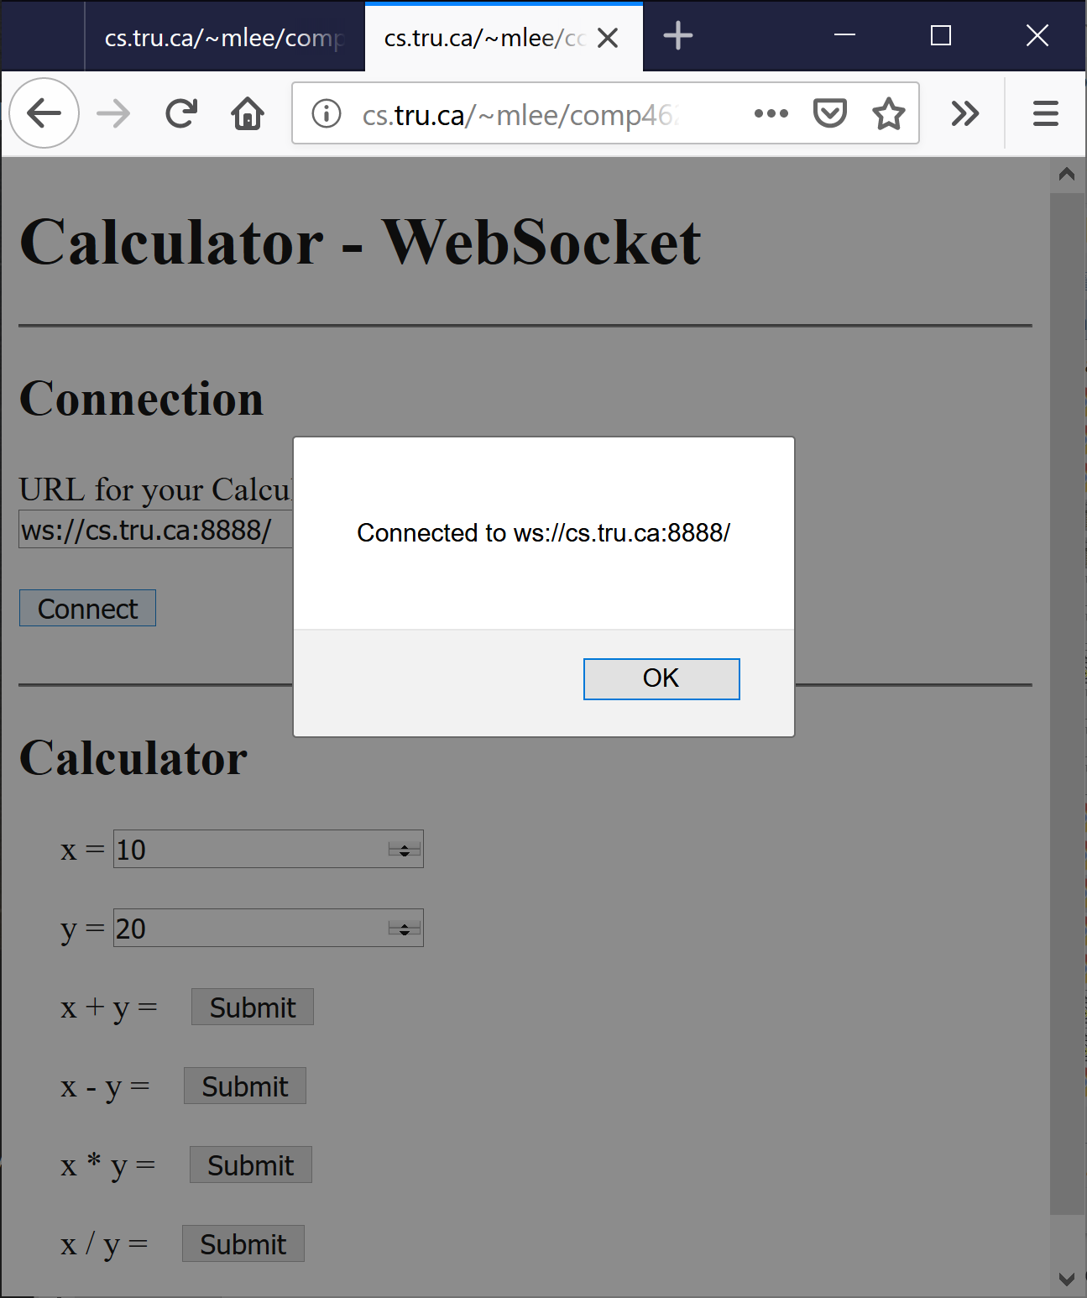

* After the connection is made, when a “Submit” button is clicked, a message is sent to the server. The server will send back the result and the result will be displayed.
* For the message exchange, let’s use JSON strings.
  + Client -> Server: {op:..., x:..., y:...}
  + Server -> Client: {op:..., result:...}

1. **How to test?**
   1. Run **your Calculator WebSocket Server**.
   2. Open calculator.html from a web browser, and test the app.
2. **How to keep running ‘node’ when you logout?**
   1. You need to run your Node web server using the ‘nohup’ command so that your web server can be tested later. For example,

$ nohup node ….js &

* 1. How to kill the above node process later?
* Find your process. E.g., $ ps -aef | grep node
* $ kill -p *process_number*

1. **Assignment**
   1. Submission

* The URL of an HTML file that uses calculator.html in 2~3.
* Total marks: 10
* Due:
  + 11:59 PM, March 17, 2022 – 10% bonus
  + 11:59 PM , March 21, 2022 – full marks
  + 11:59 PM, March 22, 2022 – 10% penalty
* Any late submission will not be accepted.
* You should not update the application after you submitted. The information of any update of a file/directory will be left on CS, and I can check the last update date and time.
* The evaluation will be usually one of pass, half-pass, and fail. Most incomplete applications will get fail.